VISIONMATE
AN IOT-BASED SMART ASSISTIVE MOBILITY STICK FOR THE VISUALLY IMPAIRED

Kolli Hema Sri Sruthi | Shreya Jha
ECE Dept, SNIST, Hyderabad | ECE Dept, SNIST, Hyderabad
21311a04u6@sreenidhi.edu.in | 21311a04y1@sreenidhi.edu.in
G. Vyshnavi | Dr. B Krishnaveni
ECE Dept, SNIST, Hyderabad | ECE Dept, SNIST, Hyderabad
21311a04x4@sreenidhi.edu.in | krishnaveni.b@sreenidhi.edu.in

ABSTRACT

Independently navigating continues to be one of the greatest challenges for people who are visually impaired, especially in changing and unpredictable environments. VisionMate is our research that attempts to help visually impaired users improve mobility, safety, and independence using a low-cost, IoT-enabled smart stick. VisionMate combines an ESP32 microcontroller to which ultrasonic, moisture, and gas sensors are connected , allowing the user to be warned of real-time obstacles and environmental hazards. Users can receive Bluetooth-based verbal feedback via a mobile application about immediate dangers. It also includes live location tracking through GPS connectivity to allow caregivers to monitor through the ThingSpeak IoT platform. The system uses a rechargeable battery and deploys intelligent power distribution by using relay and L298N driver modules. This keeps the system stable and portable for the users. While conventional blind sticks depend solely on tactile feedback from a single medium, our VisionMate connects sensing, communication, and cloud-based analytics, resulting in an assistive device. Experimental validation indicates VisionMate is effective at detecting obstacles in the vicinity of the user, wet surfaces, and smoke. This research contributes a practical, cost-effective, and transportable design to increase everyday mobility and independence for visually challenged individuals.

Keywords: Assistive Technology, IoT, Smart Stick, Vision Impairment, ESP32, Bluetooth Voice Feedback, GPS Tracking, ThingSpeak

INTRODUCTION

Vision impairment affects more than 285 million people in the world. It significantly limits one's mobility, independence, and quality of life. For many, navigating in their personal world and, more generally, in the world at large is a continual struggle, whether it is familiar or unfamiliar, urban or rural, complex or simple, with or without obstacles. Up until this point, white canes and conventional blind sticks have been the predominant mobility aids available to the blind population. These devices offer limited benefit as they depend exclusively on tactile feedback and physical contact. They also act as a barrier to prevent contact but provide no assistance with respect to collision avoidance or environmental hazard detection. These mobility aids have significant limitations because they cannot sense obstacles at a distance nor sense other dangerous conditions (e.g., smoke, wet surfaces). Furthermore, these conventional mobility aids not only do not provide any connectivity to the user or support to communicate in real-time with a caregiver, they put users in a vulnerable position when an emergency arises.

The growth of embedded systems and the Internet of Things (IoT) continues to have positive impacts on enabling innovation on a range of traditional technologies, including assistive technologies. The building and deployment apps that include sensors, connectivity, and intelligent control could help to modernize assistive technologies. Many smart device products are being made ubiquitous with built-in capacity to perform data acquisition, processing, and wireless communication through a single device that communicates and is interactive. Smart devices can provide a more responsive and autonomous mobility experience for the user. Unfortunately, while some of these advanced and smart assistive devices that are emerging today have limitations, including cost, functionality, battery life, or compatibility with mobile. These limitations restrict the opportunity for universal adoption, especially by those who have low income or are limited in options.
In this paper, we present the VisionMate, a low-cost IoT-based smart stick that can help improve spatial awareness and safety for individuals with visual impairment. The VisionMate system is designed to observe and warn the user of many environmental hazards in real time. It also includes GPS-based tracking, which is accessible in an IoT-based ThingSpeak platform. The VisionMate system overcomes standard limitations by using inexpensive hardware and an easily aligned software system with the vision of making the assistive device more accessible, usable, and reliable.
The ESP32 microcontroller is the processing unit of the VisionMate system. It takes input immediately from the HC-SR04 ultrasonic sensor to detect obstacles, the MQ6 gas sensors to detect smoke, and a 12V moisture sensor to detect slippery surfaces. These inputs are taken into consideration immediately, and subsequently they are communicated by the Arduino Bluetooth Technology Text-to-Voice Alert mobile application and through a buzzer alert included in the system. The mobile application is programmed to communicate messages with audible information informing the user about potential immediate dangers, such as "Obstacle: 9 cm ahead". The real-time nature of the feedback, which uses voice alerts over static displays, enhances the user's experience through immediate and comprehensible feedback.
Along with notifiable alerts on-device, VisionMate includes a real-time GPS tracking system based on the u-blox NEO-M8N module. The module sends the user's location to the ThingSpeak IoT platform using Wi-Fi, which caregivers and family members can view as a cloud-based dashboard for the user’s movement. The caregivers and family members have access to the user's location and can act quickly in emergencies. This is a key design feature; the VisionMate gives the user immediate alerts while allowing the caregivers and family members the ability to track when the user moves between states. The main goals of the VisionMate system are as follows:
Obstacle Detection: Use ultrasonic sensing to detect the presence of objects around the user, and notify the users using a buzzer and providing the user with mobile voice alerts.
Environmental Sensing: Detect the presence of wet or slippery surfaces with moisture sensing and detect the presence of smoke or gas leaks with an MQ6 sensor so that the user will not be put in danger.
GPS Tracking: Use a GPS module to facilitate real-time location tracking that caregivers can visualize via the ThingSpeak cloud-based platform.
Audio-based Feedback: Allow users to receive voice alerts through a Bluetooth mobile app to help users in a noisy, complex, and potentially visually demanding space.
Power Optimization: Allow for extended field use of the system by finding a rechargeable and portable supply of power.
Affordability and Accessibility: Design a low-cost and easy-to-maintain system with a minimal learning curve for a lot of users and, in particular, people who simply want to use the enhancements without prior technical knowledge.
The major contributions of this work are in its comprehensive and user-centered design. VisionMate represents a platform that incorporates many sensors, providing multiple feedbacks on the environmental surroundings of an individual. The inclusion of a GPS tracking device and IoT integration illustrated a communication pathway from interactively capturing and aggregating context-rich data to enabling communication between the user and their caregivers. Additionally, we designed the system to be energy efficient through its portable architecture (and rechargeable batteries), so it can be operated continuously without the constant need to recharge. Finally, we designed VisionMate for affordability in further altering the use of assistive technology at such high cost.

LITERATURE SURVEY

The use of embedded systems and IoT has greatly enhanced assistive mobility devices for the visually impaired. A number of studies have provided innovative ways to integrate real-time sensory feedback, wireless connectivity, and easy-to-use feedback systems.
In the study "BlinDar: An Invisible Eye for the Blind People" [1], Zeeshan Saquib and others created an integrated smart stick system using the Arduino Mega2560 microcontroller. The system incorporates ultrasonic sensors for obstacle detection, an MQ2 gas sensor for detecting fire hazards, and an ESP8266 Wi-Fi module with GPS to send location data to ThingSpeak for monitoring by caregivers. An important usability feature is the smart wristband that includes a vibration motor to improve usability in noisy, unstructured environments. There is also an RF-based stick locator function for user convenience. The authors demonstrated a low-cost and modular assistive mobility device and provided an example of how IoT can provide scalable solutions for assistive technology.
Zharfan Zakhir and Halim Maulana [14] presented a smart blind stick that used an ESP32 and focused on ground-level and surface hazards, such as puddles. The smart blind stick operated using two designed HC-SR04 ultrasonic sensors and a water level sensor to detect obstacles on the ground and above, respectively. There was also a speaker for audio feedback and a vibration motor fed from a DFPlayer Mini. They designed wheels for mobility and a push button for power management and developed the hardware using an iterative process based on a participatory design approach.
Dr. A. Veera Babu [13] presented a smart stick using an ESP32 as well and having dual ultrasonic hazard detection. They also incorporated a soil moisture sensor and a voice alert to warn users about slippery surfaces.
Loganathan et al. [6] developed a smart walking stick that has ultrasonic and infrared sensors that can detect obstacles up to 4 meters away. Vibrating motors offer tactile feedback, allowing the user to understand their environment better. The system is powered by an Arduino UNO, which allows all subsystems to run efficiently (low power and response time). A radio frequency transmitter-receiver system is also embedded so that users can find their walking stick if lost - it will sound a buzzer. Their stick is light and can fold up to be portable (ideal for everyday use).
In another work, Kher Chaitrali et al. [8] developed a smart walking stick that includes infrared sensors, RFID component, and Bluetooth technology for both detecting obstacles and navigation. They have built an Android application that creates an interface with voice feedback and will allow a caregiver to follow the current location of the user. They also included RFID tags on public infrastructure in order to guide individuals indoors where GPS generally fails. Their hybrid design is compact, modular, and inexpensive, and potential future work could include features such as cloud analytics and emergency notifications.
The research described in [5] further increases the possibilities of smart canes by fusing the Wi-Fi and Bluetooth connectivity provided by a Raspberry Pi-based image processing system. A camera and ultrasonic sensor work together to perform real-time recognition of obstacles, accompanied by verbal descriptions of surroundings for user interpretation. Additionally, GPS can be used for navigation support, while vibration and audio alerts augment cane tracking for the user and obstacle warnings using tactile and auditory modes. This system creates an advanced multimodal feedback system with tactile, auditory, and visual feedback for dynamic urban environments.
The field of smart stick technology for the blind and visually impaired has evolved significantly, with many examples now including a variety of sensors, including ultrasonic, infrared, and moisture sensors, to support blind users' sense of space (obstacle detection and awareness of terrain). The integration of sensors to control vibration motors, GPS, GSM, RF, and Bluetooth capabilities, as well as integration with voice and health monitoring devices, will empower users to have a greater sense of safety, security, privacy, and independence. Although smart stick technology is progressing and evolving, it is still in a development stage, and challenges such as inherent lack of reliability of sensors, limited performance in indoor navigation, limited range of the detection range, and power Hungry levels of performance from smart modules remain problematic. Smart sticks that combine several sensing technologies will require significant power. Too much processing from demanding and sophisticated image processing from an external microcontroller delays emergency alerts. Moreover, voice- and application-based controls may be difficult for elderly individuals. Nonetheless, smart stick technology continues to develop and improve usability, reliability, and accessibility.

METHODOLOGY

The development of VisionMate, an IoT assistive smart stick, followed a systematic engineering process: from hardware selection to system design and integration, then real-life testing. In VisionMate, the principles of modularity, power efficiency, and accessibility for vision-impaired users guided a logical architecture. In this architecture, each subsystem contributed to an overall capability set of safety, mobility, and usability.
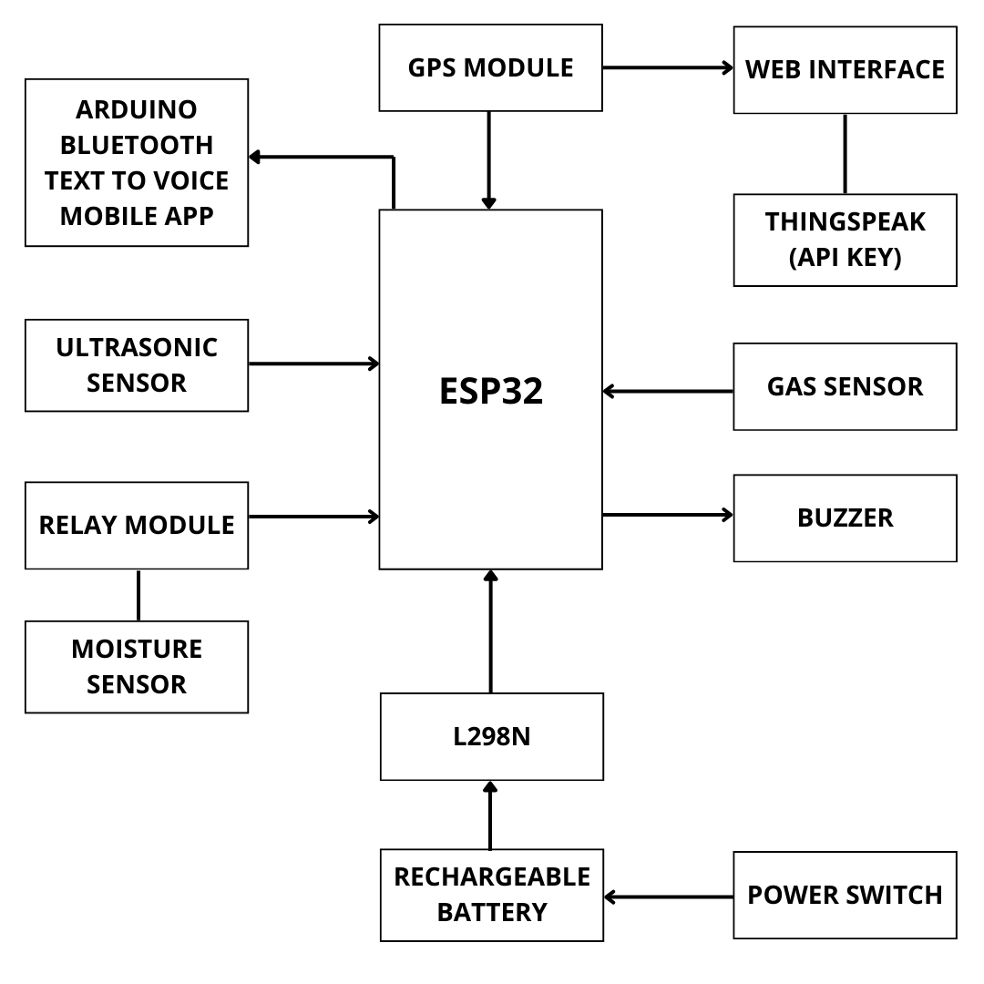3.1 System Architecture & Microcontroller
VisionMate works on the ESP32 microcontroller. The ESP32, a dual connectivity chip (Wi-Fi and Bluetooth), was selected because of its low power, real-time capabilities, and extensibility. The ESP32 processed all sensor inputs, executed control logic, and transmitted data to the cloud and local mobile application. It facilitated interactions involving multiple modules of sensors, buzzers, a mobile application interface, and GPS.
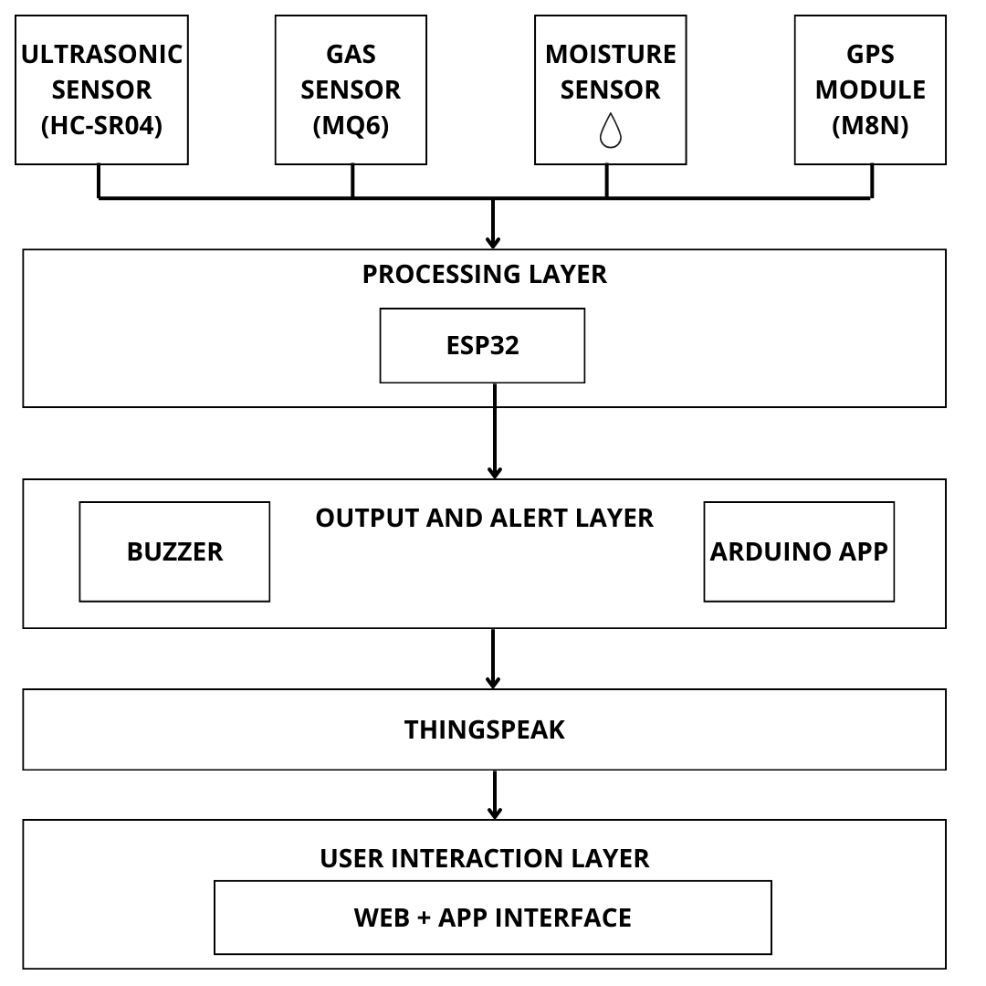
3.2 Obstacle Detection System
Obstacle detection was achieved using an HC-SR04 ultrasonic sensor, which sends out sound waves to be measured by the time for the echo to return. If an obstacle was detected at a distance less than 30cm, the ESP32 activated a buzzer to produce a high-pitched audio warning on the stick. A Bluetooth-based text-to-voice message to be spoken via the Arduino mobile application: "Obstacle ahead at 30 centimeters." The system provides a dual alert mechanism, additionally providing tactile feedback as well as audible feedback, while also providing contextual information through voice.

3.3 Environmental Hazard Detection
To mitigate safety threats when an environment is less amenable to detection, we also integrated two sensors:
MQ6 gas sensor: The MQ6 gas sensor detects flammable gases and smoke. When it continues to monitor flammable gases and the concentration level rises above a threshold, we set, it will create an alert through the buzzer but also with a mobile voice prompt.
Moisture sensor: (12V) Detect whether the surfaces are wet or slippery. The moisture sensor is wired through a relay module that is then controlled by the ESP32 for expected safe high-voltage operations using a relay to turn the moisture sensor on and off. Once aware of the wet surface, the system will provide an alert via a cautionary voice prompt and buzzer warning, and you can address the risk.
These sensors give users situational awareness when in kitchens, outdoor pavements, or in industrial situations where gas leaks or wet surfaces threaten real-life safety.

3.4 GPS-based Tracking/IoT Connectivity
For real-time latitude/longitude tracking, we are using the NEO-M8N GPS Module. The GPS module obtains the user's lat/lon and feeds this back to the ESP32, which transmits the data via Wi-Fi to the ThingSpeak Cloud platform. The caregiver can see where they currently are. The location data that's being sent will be displayed on the ThingSpeak dashboard, and timely intervention can help the user in important emergent situations or when disoriented. The cloud tracking of a user's location with VisionMate recognizes this device's usefulness outside of immediacy.

3.5 Mobile App & Bluetooth Feedback
The Arduino Bluetooth Text-to-Voice mobile application acts as the human-interactive interface that receives sensory input from the ESP32 over Bluetooth, as well as gives audible feedback to users without needing their screen. The alerts provided by the application are dependent on the obstacle distance, wet surface indication, and gases. The application is lightweight, responsive, and friendly for the user.
The combination of the mobile application and Bluetooth ensures that there is unbroken interaction wherever you are. Even if there is minimal Wi-Fi coverage with regard to your application, you will receive reliable feedback directly to the smartphone.

3.6 Power Supply & Voltage
Power supply to the whole system is given by rechargeable lithium-ion batteries, which was chosen due to their high energy density and small size. In power supply, voltage regulation will be a critical component to properly powering the components at 3.3V (ESP32), 5V (relay and ultrasonic sensor), and 12V (DC motor for pump). The L298N motor driver module has been adopted for use, not for its desired purpose (control of motor), but for its potential as a power interface. With the L298N relay motor driver module supplying dedicated and stable voltage to the sensors and relays at optimum voltages, there was no strain on the 3.3V and 5V regulator aboard the ESP32.
Furthermore, the relays provide on/off switching for the unnecessary power consumption of the other high draw component (moisture sensor). This means that the moisture sensor will only receive power if activated, ideally improving the battery life and also prolonging the life of the sensors.

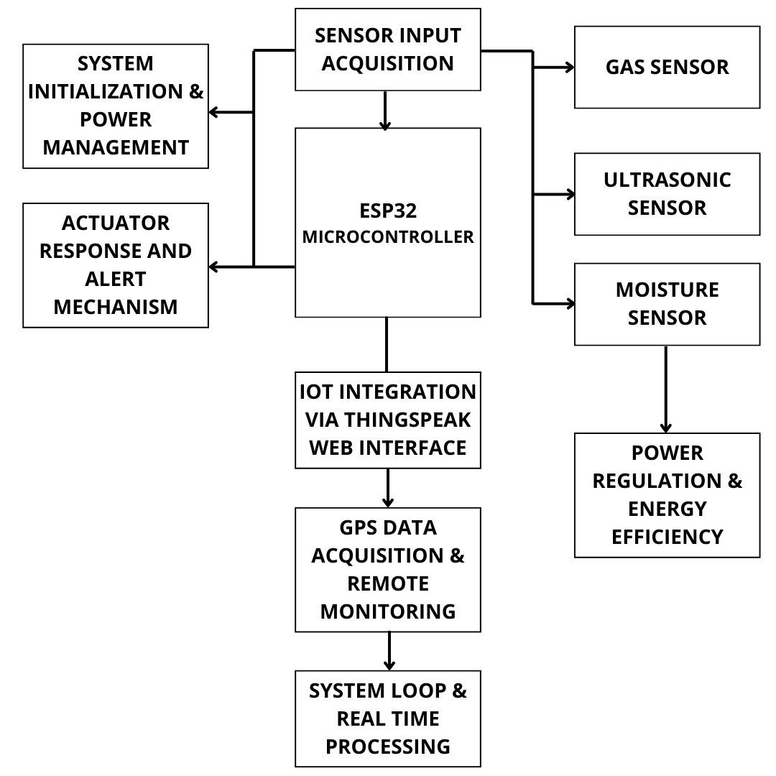

RESULTS AND DISCUSSIONS
The VisionMate prototype was developed, tested, and validated in the real world to assess its impact on improving mobility and safety with its visually impaired users. Each sensor subsystem, cloud connectivity, and feedback system was characterized individually and in combination for performance, responsiveness, and reliability.
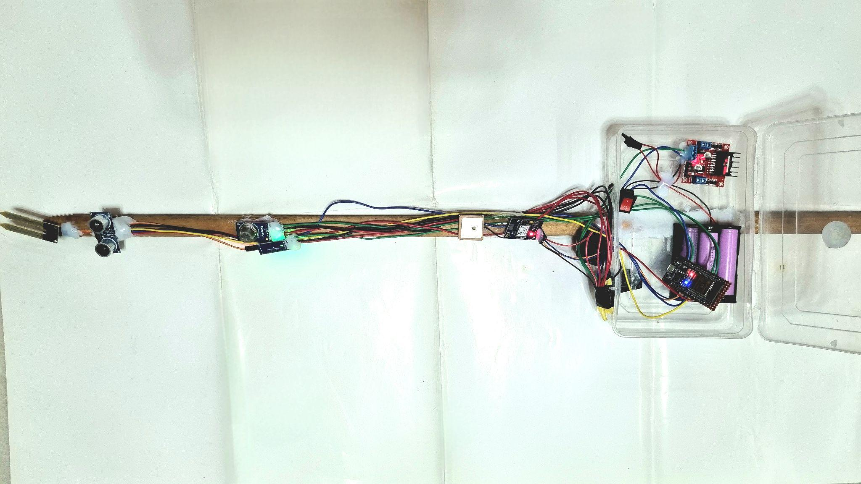
Obstacle detection was consistent and reliable with the HC-SR04 ultrasonic sensor. The ultrasonic sensor reported object detection within the range of 2 cm to 50 cm with a tolerance of ±2 cm. The VisionMate responded in real-time by activating a buzzer and triggering the mobile app to convey proximity alerts via voice-based alerts. This dual-feedback system allowed the user to quickly perceive and act on obstructions without physical contact.
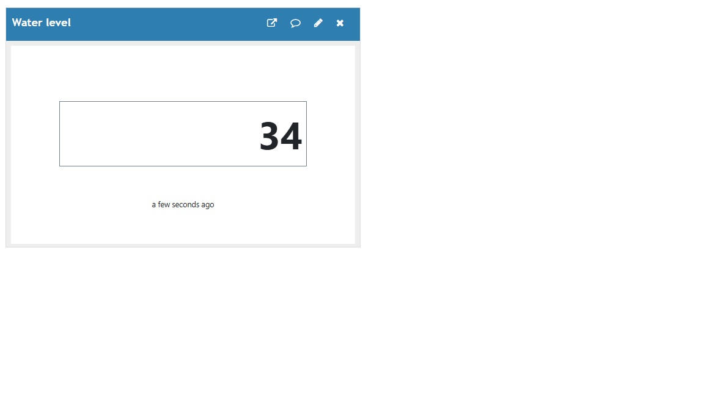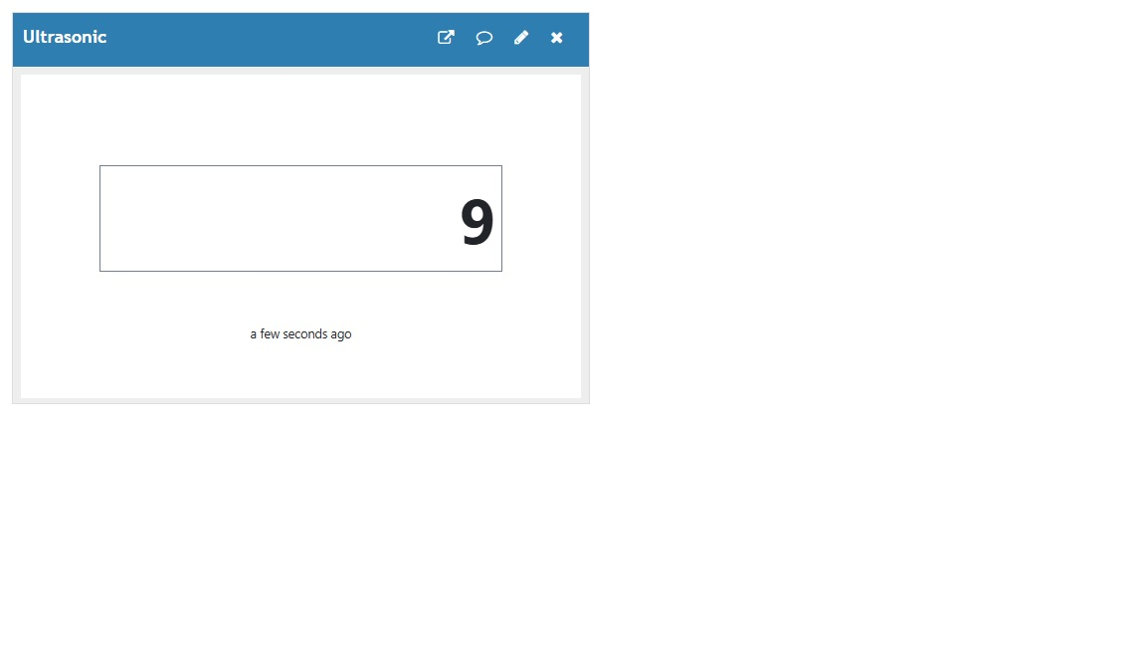
Environmental hazard detection was also reliable. The MQ6 gas sensor reported LPG and smoke concentrations above preset thresholds, providing both a buzzer and voice-based alert. This function was useful for simulating indoor kitchen contexts where blind users can often be vulnerable due to lack of contact with potentially dangerous invisible gas leaks. Similarly, the 12V moisture sensor accurately reported on wet patches and puddles to allow users to receive timely warnings before slips, falls, or ventures into unsafe terrain.
The GPS module (NEO-M8N) sent accurate location to the ThingSpeak cloud at intervals chosen by the user according to the ESP32 firmware. The online dashboard visualized live coordinates, allowing care providers to verify where the user was located. In open-air space there was little latency in conveying the message; however, in tight or obscured urban areas where there may be high-rise buildings or trees, the transmitted location may be delayed (5–10 seconds). This would be normal behavior from a GPS module in a built environment.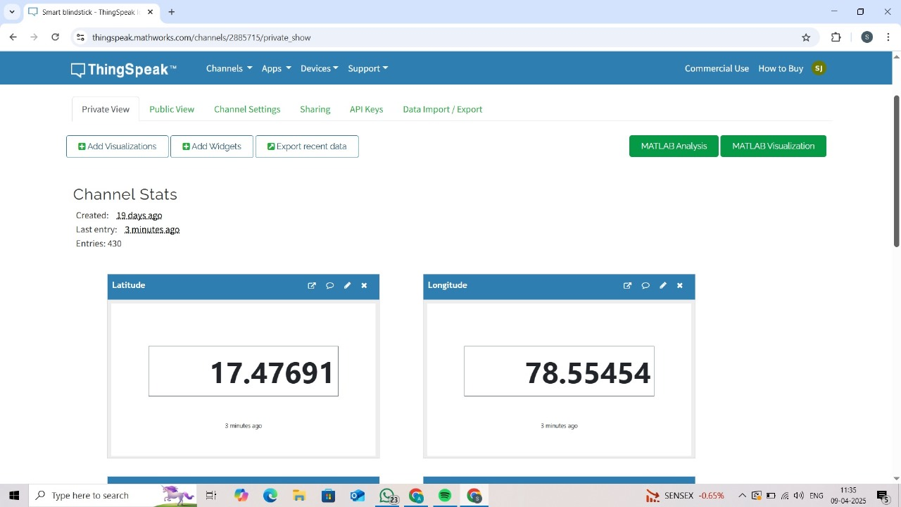
The Bluetooth text-to-voice mobile application provided reliable spoken alerts in the delivery messages, like "Obstacle: 9 cm" or "Water detected: 38%." This mode of communication was key in delivering hands-free wayfinding, especially in louder environments where visual cues or traditional buzzers would not suffice.
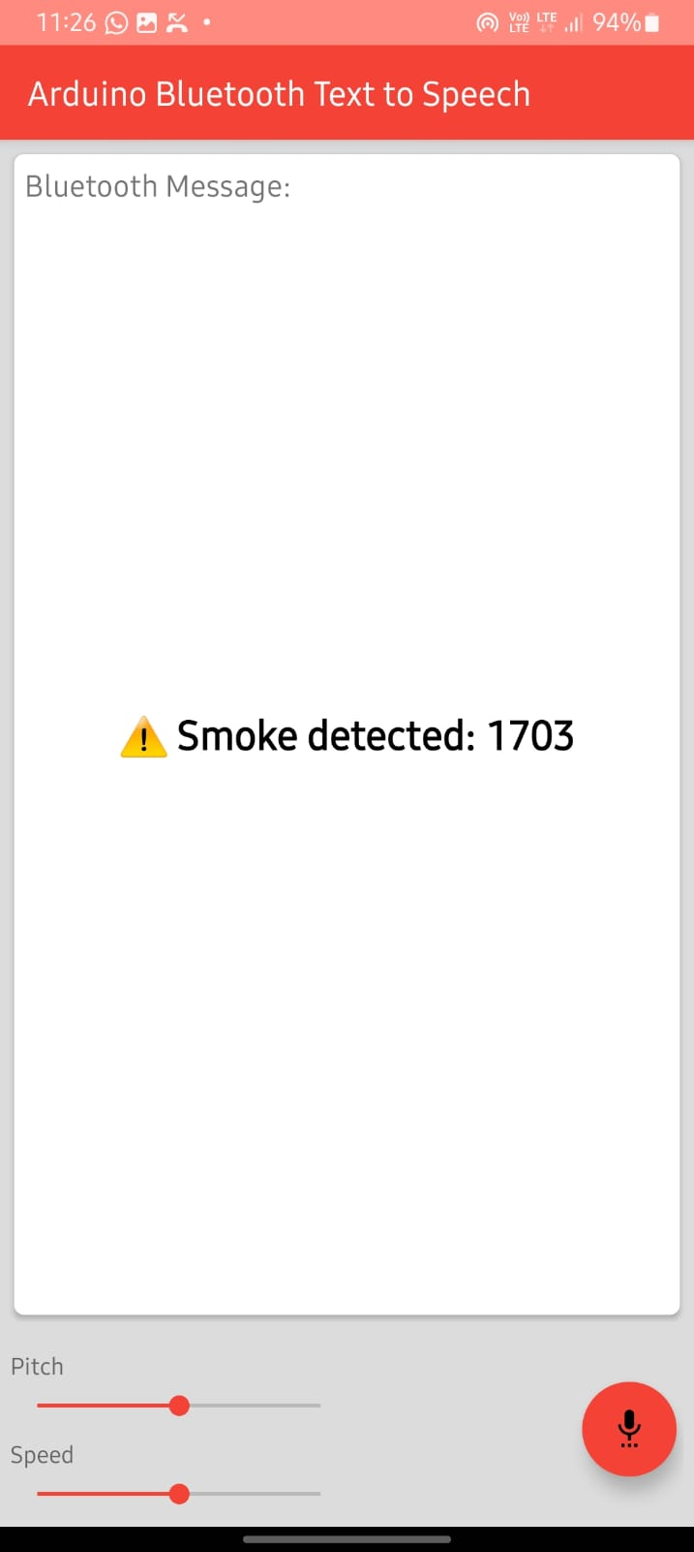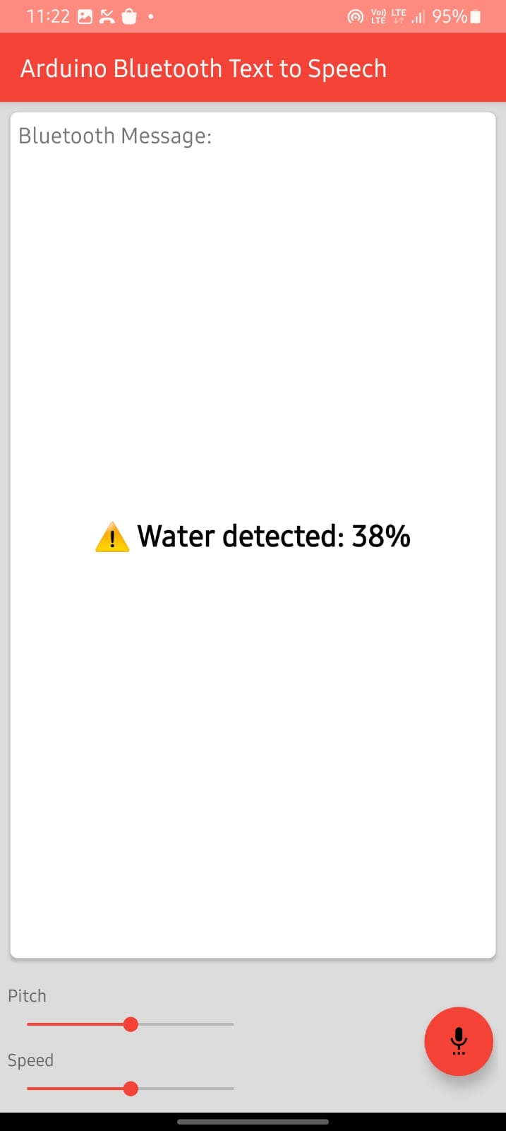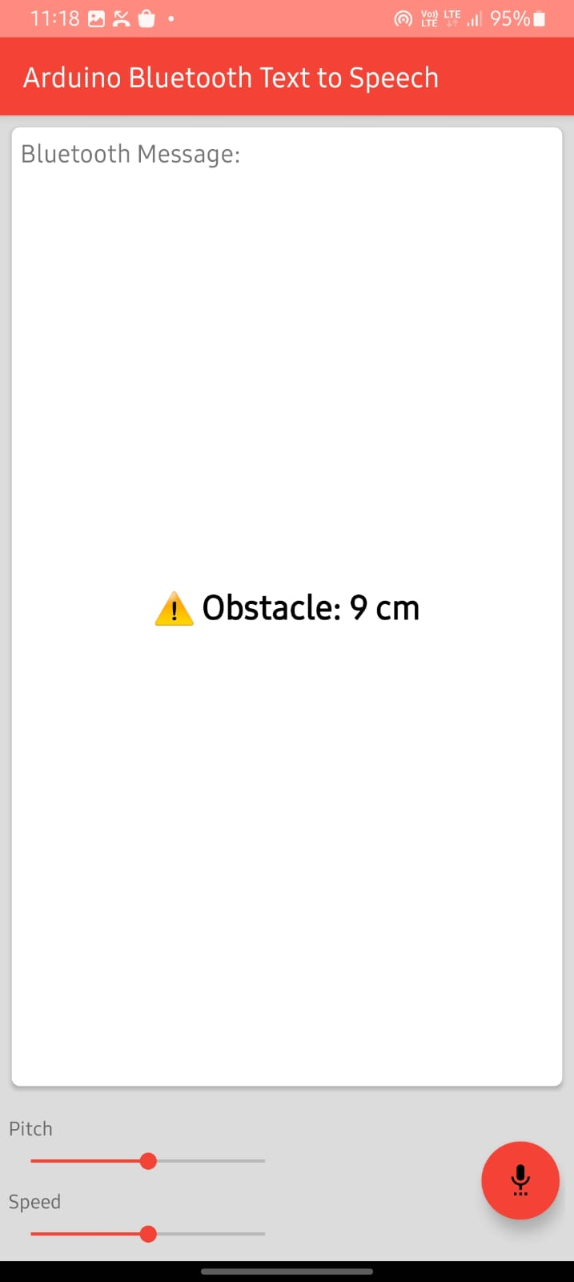
In conclusion of the discussions, VisionMate demonstrated an acceptable, modular design. The two limitations of improving energy configuration and GPS latency can be explored in the future. Overall, the prototype fulfilled the core promise that it was designed for: real-time, multi-sensory awareness and remote monitoring to independently and safely allow users to access the world.

CONCLUSION AND FUTURE SCOPE
Our research presented VisionMate, an intelligent assistive device that aims to enhance the navigation process for visually impaired people. The system features a combination of sensors (ultrasonic, moisture, and gas), GPS, and Bluetooth communication to offer the user awareness of their surroundings with tactile and audible alerts or feedback. With the ESP32 microcontroller's dual connectivity, VisionMate operates with a custom-made mobile application and uploads "live" location data and alerts to the ThingSpeak IoT platform, which keeps both users and caregivers connected and informed, improving safety and mobility regardless of how independent a user may feel.
The results of prototype implementation suggested that VisionMate works consistently in different environmental conditions. Hazard detection modules, such as MQ6 gas and moisture sensors, were helpful in detecting hazards, while GPS tracking was used for live remote tracking. The overall compact, low power, and cost make the object practical for people wanting an assistive device without any barriers.
Looking forward, there are many means of improving the functionality and scalability of VisionMate. Attaching camera modules with edge-processing capabilities could classify detected obstacles, allowing the system to sense whether it has encountered static objects, vehicles, or people. Additionally, we could improve indoor navigation using RFID or Li-Fi systems, which allow users to navigate inside enclosed or GPS-limited spaces. When combined with machine learning algorithms, VisionMate could learn users' behaviors and environmental patterns to deliver predictive feedback and support navigation.
Future developments could include automatic emergency response systems that could trigger SMS alerts or phone calls when they detect a fall or unusual inactivity. Battery life can be optimized for long-distance outdoor use with dynamic power management and low-energy components. More widespread testing with visually impaired individuals will help refine the design, in a human-centered way, by ensuring usability, comfort, trust, etc.
REFERENCES
[1] Zeeshan Saquib, Vishakha Murari, and Suhas N. Bhargav, “BlinDar: An Invisible Eye for the Blind People,” 2017 2nd IEEE Int. Conf. Recent Trends Electron. Inf. Commun. Technol., May 2017, India.
[2] N. Dey, P. Ghosh, R. De, A. Paul, C. Mukherjee, and S. Dey, “Ultrasonic Sensor Based Smart Blind Stick,” in Proc. 2018 IEEE Int. Conf. Current Trends toward Converging Technologies, Coimbatore, India, 2018.
[3] M. P. Agrawal and A. R. Gupta, “Smart Stick for the Blind and Visually Impaired People,” in Proc. 2nd Int. Conf. Inventive Commun. Comput. Technol. (ICICCT), 2018, pp. 1–5.
[4] S. Kulkarni, A. Biradar, A. Galphade, and M. Ishi, “SMART BLIND STICK WITH GPS AND GSM MODULE USING ARDUINO NANO,” Int. Res. J. Modernization Eng. Technol. Sci., vol. 6, no. 3, pp. 3648–3650, Mar. 2024.
[5] T. S. Aravinth, “WiFi and Bluetooth-Based Smart Stick for Guiding Blind People,” in Proc. 3rd Int. Conf. Intell. Sustainable Syst. (ICISS), 2020, IEEE Xplore, ISBN: 978-1-7281-7089-3.
[6] N. Loganathan, K. Lakshmi, N. Chandrasekaran, S. R. Cibisakaravarthi, R. H. Priyanga, and K. H. Varthini, “Smart Stick For Blind People,” in Proc. 6th Int. Conf. Adv. Comput. Commun. Syst. (ICACCS), 2020.
[7] A. Pathak, A. P. Singh, H. Sharma, S. Kumar, and Y. Saini, “RAPID RESPONSE SMART BLIND STICK WITH OBSTACLE DETECTION USING ARDUINO,” Int. J. Tech. Res. Sci., vol. 6, no. 8, pp. 14–17, 2021.
[8] C. S. Kher, Y. A. Dabhade, S. K. Kadam, S. D. Dhamdhere, and A. V. Deshpande, “An Intelligent Walking Stick for the Blind,” Int. J. Eng. Res. Gen. Sci., vol. 3, no. 1, pp. 1057–1062, Jan.–Feb. 2015.
[9] V. Jadhav and Narayanrao, “Safety Stick For Blind People Using Microcontroller,” Int. J. Eng. Dev. Res., vol. 4, no. 2, pp. 986–990, 2016.
[10] R. Radhika, P. G. Pai, R. S. Rakshitha, and R. Srinath, “Implementation of Smart Stick for Obstacle Detection and Navigation,” Int. J. Latest Res. Eng. Technol. (IJLRET), vol. 2, no. 5, pp. 45–50, May 2016.
[11] O. O. Oladayo, “A Multidimensional Walking Aid for Visually Impaired Using Ultrasonic Sensors Network with Voice Guidance,” I.J. Intell. Syst. Appl., vol. 8, pp. 53–59, 2014.
[12] A. A. Elsonbaty, “Smart Blind Stick Design and Implementation,” Int. J. Eng. Adv. Technol. (IJEAT), vol. 10, no. 5, pp. 17–20, Jun. 2021.
[13] A. V. Babu, V. V. Krishna, K. Naveen, and M. V. Kumar Reddy, “Smart Blind Stick Using ESP32,” Int. J. Res. Appl. Sci. Eng. Technol. (IJRASET), vol. 12, no. 3, pp. 3403–3409, Mar. 2024.
[14] Z. Zakhir and H. Maulana, “Smart Blind Stick Design Using HC-SR04 Sensor and ESP 32 Based Water Level Sensor to Improve the Mobility of Blind Persons,” TSABIT J. Comput. Sci., vol. 1, no. 2, pp. 60–67, Dec. 2024.
[15] G. Pavankumar, U. Jyothika, S. Neeha, V. S. R. Kumarreddy, Y. V. Tejarohith, and S. Naveenkumar, “SMART BLIND STICK BASED ON WIRELESS SENSOR NETWORK AND INTERNET OF THINGS,” Dogo Rangsang Res. J., vol. 13, no. 4, pp. 232–237, Apr. 2023.

